Colman Junior School


SEND Information Report 2025-26

Updated November 2025
What kinds of SEND are provided for at Colman Schools?
Our schools currently provide additional and/or different provision for a range of needs, including:
• Communication and interaction, for example, autistic spectrum disorder, and speech and language difficulties
• Cognition and learning, for example, dyslexia, dyspraxia
• Social, emotional and mental health difficulties, for example, attention deficit hyperactivity disorder (ADHD)
• Sensory and/or physical needs, for example, visual impairments, deafness and sensory processing difficulties
• Moderate/severe/profound and multiple learning difficulties
What is SEND?
SEN stands for Special Educational Needs and Disabilities. The SEN Code of Practice (2015) states: A pupil or young person has SEN if they have a learning difficulty or disability which calls for special educational provision to be made for him or her. A pupil of compulsory school age or a young person has a learning difficulty or disability if he or she:
• has a significantly greater difficulty in learning than the majority of others of the same age, or
• has a disability which prevents or hinders him or her from making use of facilities of a kind generally provided for others of the same age in mainstream schools or mainstream post-16 institutions.

Our SEN Profile
Our 2025-26 SEN profile consists of 19.4% of pupils having at least one identified area of need. Across the United Kingdom schools generally have around 12% of pupils with SEND. This means we support a lot of pupils! 5.3% of pupils at Colman Junior School have an EHCP.
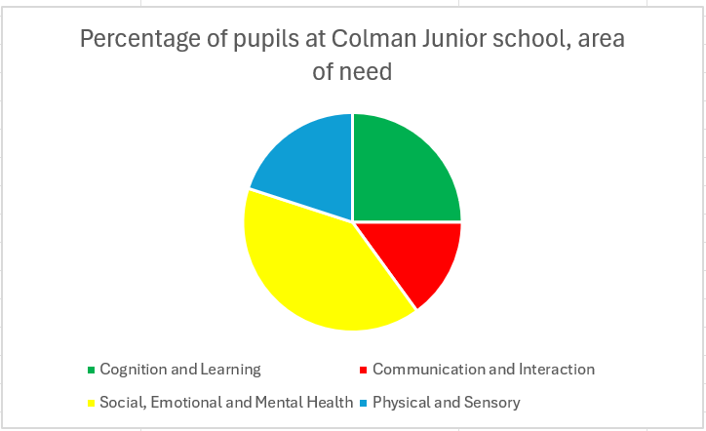

How will we involve pupils and parents?
We will have an early discussion with the pupil and their parents when identifying whether they need special educational provision. These conversations will make sure that:
▪ Everyone develops a good understanding of the pupil’s areas of strength and difficulty.
▪ Parents’ concerns are heard.
▪ Everyone understands the agreed outcomes sought for the pupil.
▪ Everyone is clear on what the next steps are.
We will formally notify parents when it is decided that a pupil will receive SEN support. We also ensure that pupils are also supported in being made aware of the support they receive and why this is important for them.
Identifying and Assessing SEND at Colman Schools
We will assess each pupil’s current skills and levels of attainment on entry, which will build on previous settings and Key Stages, where appropriate. Class teachers will make regular assessments of progress for all pupils and identify those whose progress:
▪ Is significantly slower than that of their peers starting from the same baseline
▪ Fails to match or improves the pupil’s previous rate of progress
▪ Fails to close the attainment gap between the pupil and their peers
This may include progress in areas other than attainment, for example, social communication. Slow progress and low attainment will not automatically mean a pupil is recorded as having SEN.
When deciding whether special educational provision is required, we will start with the desired outcomes, including the expected progress and attainment, and the views and the wishes of the pupil and their parents. We will use this to determine the support that is needed and whether we can provide it by adapting our core offer, or whether something different or additional is needed.
We also use a range of screening and assessment methods which include;
• Accelerated Reader
• PIXL
• British Picture Vocabulary Scale (BPVS)
• Times Table Rock Stars
• Wellcomm

How will we asses and review our SEN pupils progress?
As a school we follow the graduated approach of: Assess, Plan, Do, Review. The class teacher will work with the SENCO to carry out a clear analysis of the pupil’s needs. This will draw on:
▪ The teacher’s assessment and experience of the pupil
▪ Their previous progress and attainment or behaviour
▪ Other teachers’ assessments, where relevant
▪ The individual’s development in comparison to their peers and national data
▪ The views and experience of parents
▪ The pupil’s own views
▪ Advice from external support services, if relevant
▪ The assessment will be reviewed regularly.
All teachers and support staff who work with the pupil will be made aware of their needs, the outcomes sought, the support provided, and any teaching strategies or approaches that are required. We will regularly review the effectiveness of the support and interventions and their impact on the pupil’s progress.
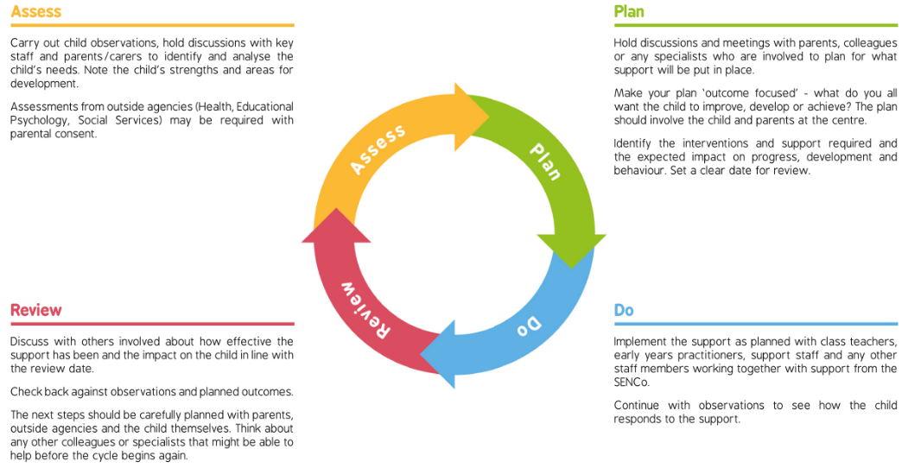
Our Approach to Teaching and Supporting Pupils with SEND
As a school we use a personalised approach to SEN support. This is led by the class teacher and supported by the SENCo, to make sure each pupil has the right level of support for them: We start with a universal approach of inclusive quality first teaching for all involving personalised adjustments for learners.

Universal
Inclusive quality first teaching for all and adjustments made by the teacher
Targeted
Specific, named interventions and additional support for pupils.
Specialist
Outside agencies, such as specialist teachers, or educational psychologists may be required for more advice.

Evaluating Effectiveness of SEN provision at Colman Schools
We evaluate the effectiveness of provision for pupils with SEN by:
▪ Reviewing pupils’ individual progress towards their goals each term
▪ Reviewing the impact of interventions after 6 weeks
▪ Using pupil questionnaires
▪ Monitoring by the SENDCo
▪ Using provision maps to measure progress
▪ Holding annual reviews for pupils with Education, Health and Care Plans (EHCP’s)

What is Inclusive Quality First Teaching?
Inclusive quality first teaching combined with our school process for assessing, planning, implementing, tracking, monitoring and reviewing is essential in supporting pupils. For us as a school this means:
1. A planned curriculum which is well sequenced.
2. Adaptive teaching approaches that build on cognitive strategies (subject specific or memorisation techniques) and metacognition (what we use to monitor of control our cognition e.g. problem solving though trial and error).
3. Lessons are planned and specific strategies are in place to support SEND learners where necessary.
4. Adapted learning is evident in all lessons.
5. The classroom environment is inclusive of learners needs.
6. Purposeful interventions where necessary to allow pupils to catch up and accelerate progress.
7. Opportunities for trips and visits are offered to all pupils.
8. Wellbeing is part of our everyday school life.

Additional Support
We have 6 teaching assistants who are trained and supported to deliver and range interventions such as emotion coaching, Sensory Circuits, Bucket Time and Precision Teaching. Teaching assistants will support pupils in a small group and/or 1:1 basis when a need for specific and personalised interventions and/or support is identified though our graduated approach to SEND.
We may work with the following agencies to provide support for pupils with SEN:
▪ Access Through Technology
▪ Speech and Language Team
▪ Nelsons Journey
▪ Norfolk Early Help
▪ Educational Psychologist
▪ Specialist Teachers
▪ Paediatricians
▪ Physiotherapists
▪ Occupational Therapists
▪ Schools and Communities Team
▪Family Hub
▪ Virtual School Sensory Support
▪ SEND and Inclusion Team
▪ REDI team
▪ People from Abroad Team
Staff Skills and Training
Our SENCO works full time to manage SEND provision. We have a team of 6 Teaching Assistants, including Higher Level Teaching Assistants (HLTAs) who are trained to support Teaching and Learning as well as provide SEN support. Our Teaching Assistants and HLTAs:
▪ Support pupils to access the curriculum.
▪ Empower pupils to develop effective strategies that enable them to become independent learners.
▪ Support the implementation of scaffolding and specialist support strategies in the classroom. Observe and record achievements and concerns.
▪ Attend reviews and meetings as requested
▪ Keep pupils focused on learning activities during lessons.
▪ Provide live feedback to pupils in lessons in relation to their learning.
▪ Deliver small group interventions. Staff have been trained in a range of support and interventions, including:
• Accelerated Reader
• Sensory Circuits
▪ Emotion Coaching
• Times Tables Rock Stars
• Phonics

How do we make sure all pupils are included in opportunities at school?
We are an inclusive community:
▪ All of our enrichment activities and school visits are available to all our pupils.
▪ All pupils are encouraged to go on our residential trip(s) as this is an important part of our curriculum offer.
▪ All pupils are encouraged to take part in sports days and special workshops.
▪ No pupil is ever excluded from taking part in these activities because of their SEN or disability.
You can also take a look at the school accessibility plan which is available on our website or can be requested form our office.
How will we support pupils moving into new year groups/classes and transitioning to High school?
▪ Meetings with nurseries to make a transition plan for pupils with SEN starting school
▪ Transition booklets about the new class/school
▪ Visits to the new class or school, sometimes with extra visits planned for pupils with additional needs usually in the summer term before transition
▪ Transition reviews in Year 5 for pupils with EHCPs
▪ Attendance of the feeder school at annual review if appropriate
▪ Transition planning with High Schools for pupils with SEN
▪ Additional back to school visits following the summer break
▪ Teachers visiting the pupils in their classroom or at home
We can also offer support for parents and careers in choosing and applying for high school as we know this can be a difficult task!

What if I am concerned or have a complaint about SEND Provision at Colman Schools?
As a school we would always want to hear your concerns. Ideally, we would like to talk things though as we want to work in partnership with our parents and carers. Our class teachers make a great first point of contact for your concerns. However, if you are not happy with our SEN provision then complaints should be made to the SENCO in the first instance. They will then be referred to the school’s complaints policy. The parents of pupils with disabilities have the right to make disability discrimination claims to the first tier SEND tribunal if they believe that our school has discriminated against their pupils. They can make a claim about alleged discrimination regarding:
▪ Exclusions
▪ Provision of education and associated services
▪ Making reasonable adjustments, including the provision of auxiliary aids and services.
The Norfolk Local Authority Local Offer
The Norfolk Local Offer website is a great source of support for parents/carers who have a chat that has SEND.
The website can help you:
• Find information on support in education
• Learn about special needs services that can help pupils, young people and their families
• Find a support network - parents, groups and organisations
• Get guidance and advice about how to help a young person plan their adult life https://www.norfolk.gov.uk/children-and-families/send-local-offer

What makes Colman Unique?
Colman Schools play host to a Deaf Resource Base (DRB).
We have provision for six placements that are open to deaf children throughout the county.
Our deaf children are valued members of our school and are fully included in all aspects of school life. They learn alongside their mainstream peers, either in class or in a smaller group.
The deaf pupils are encouraged to have a positive deaf identity and have a weekly ‘deaf time’ where they study and discuss aspects of deaf culture with a Teacher of the Deaf and other visiting members of the deaf community.
Pupils throughout the school are encouraged to value the cultural diversity that our deaf children bring to the school and learn BSL which is a language of our community and seen in class, during assemblies and of course, on the playground!
This is part of Norfolk’s ‘local offer’ for children with Special Educational Needs and Disabilities.
You can also find more information about the support for deaf children across the county provided by Virtual School Sensory Support.

Contact Details
All of our class teachers are happy to discuss individual pupils with parents/carers.
Alternatively you can contact the SENCO or SEND Governor
Our SENCO is Kelly Jones, senco-colmanschools@colmanschools.org.uk
SEND Governor – Jo Brown

This SEND Information Report, which forms part of the Norfolk Local Offer for learners with Special Educational Needs or Disability (SEND) in accordance with the Special Educational Needs and Disability Code of Practice, January 2015 (Chapter 6, section 6.79). SEND This report is also fully compliant with Regulation 51 and Schedule 1 of the Special Educational Needs and Disability Regulations 2014. The information published will be updated annually. The Information Report also applies to all pupils who are looked after by the local authority and have SEND.

